Compiler Design Lab Manual
Session 1: program to remove whitespaces and comments using lex tool
Lex
- Lex is a tool or a computer program that generates Lexical Analyzers
- converts the stream of characters into tokens.
- The Lex tool itself is a compiler. The Lex compiler takes the input and transforms that input into input patterns.
- It is commonly used with YACC(Yet Another Compiler Compiler). It was written by Mike Lesk and Eric Schmidt.
Lex program structure
A Lex program consists of three parts and is separated by %% delimiters:-
Declarations
%%
Translation rules
%%
Auxiliary procedures
Declarations: The declarations include declarations of variables.

Transition rules: These rules consist of Patterns and Actions.

Auxiliary procedures: The Auxiliary procedures section holds auxiliary functions used in the lexical analysis process.
Lex program creation
- In the first step the source code which is in the Lex language having the file name 'File.l' gives as input to the Lex Compiler commonly known as Lex to get the output as lex.yy.c.
- After that, the output lex.yy.c will be used as input to the C compiler which gives the output in the form of an 'a.out' file, and finally, the output file a.out will take the stream of character and generates tokens as output.
Session 1a: Remove whitespaces and comments using lex tool
Step1: Use LEX and YACC Compiler in Google Colab
Step 2: Install prerqeuisites( click on show code)
Step 3:click on +code in menu
Step 4: enter lex program
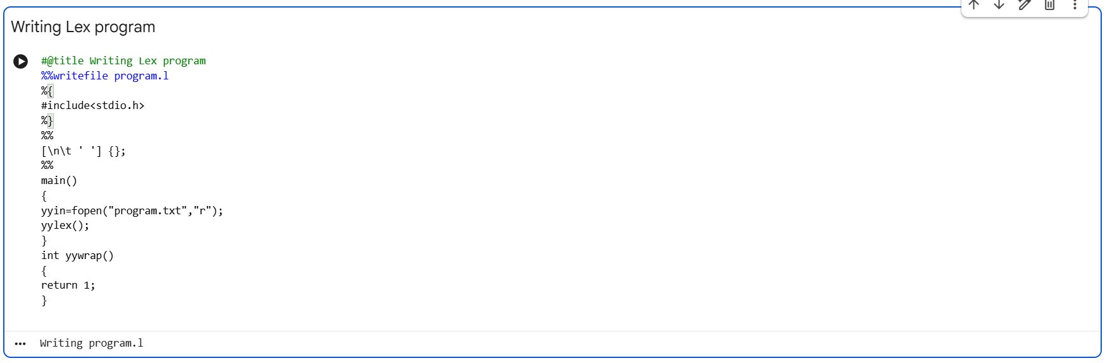

Step 5:input to program
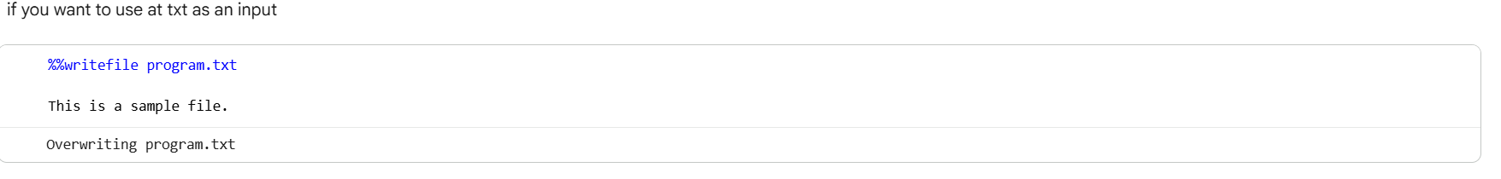

Step 6: Shell Execution(compile and running
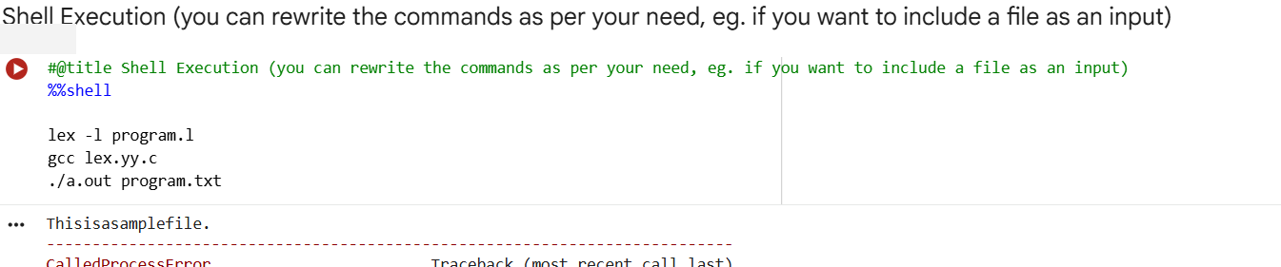

session 1b:program to remove comments using lex tool
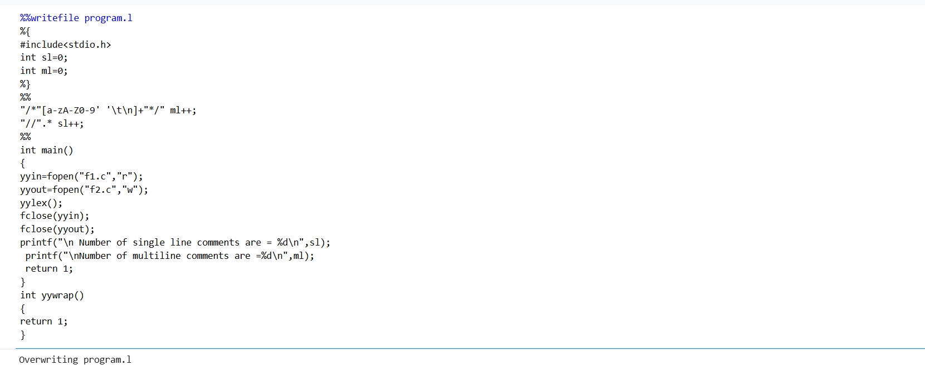
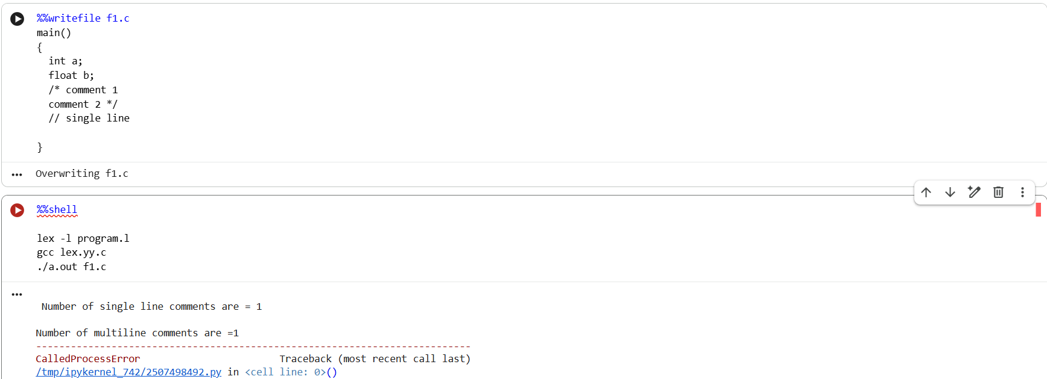
Lex predefined variables and functions
- char *yytext: Points to the string matching the current regex pattern.
- int yyleng: Holds the exact length of the matched string.
- FILE *yyin: Points to the input source file stream.
- FILE *yyout: Points to the destination output file stream.
- int yylineno: Tracks the current line number of the input file.
- YYSTYPE yylval: Holds values associated with tokens when communicating with Yacc/Bison parsers.
functions
- int yylex(void): Invokes the scanner to partition input into matched tokens.
- int yywrap(void): Fires automatically when the input stream reaches EOF.
Session 4:
WRITE A C PROGRAM TO IMPLEMENT RECURSIVE DECENT PARSER FOR GRAMMAR:-
E->E+T|T
T->T*F|F
F->id
#include<stdio.h>
#include<string.h>
#include<ctype.h>
int i,err;
char inp[10];
void E();
void E1();
void T();
void T1();
void F();
void main()
{
i=0,err=0;
printf("Enter String: ");
scanf("%s",inp);
E();
if(strlen(inp)==i && err==0)
printf("\t\t*****STRING ACCEPTED!!!!!!!!!*****\n\n");
else
printf("\t\t*****STRING NOT ACCEPTED!!!!*****\n\n");
}
void E()
{
T();
E1();
}
void E1()
{
if(inp[i]=='+')
{
i++;
T();
E1();
}
}
void T()
{
F();
T1();
}
void T1()
{
if(inp[i]=='*')
{
i++;
F();
T1();
}
}
void F()
{
if(isalnum(inp[i]))
i++;
else if(inp[i]=='(')
{
i++;
E();
if(inp[i]==')')
i++;
else
err=1;
}
else
err=1;
}
Session 5: program to remove left recursion
include <stdio.h>
#include <string.h>

int main() {
char rule[100];

// 1. Accept standard production rule format
printf("Enter production rule (e.g., A->Aa|b): ");
if (scanf("%99s", rule) != 1) return 1;

char lhs = rule[0]; // Left-hand side non-terminal character

// 2. Identify direct left recursion layout (e.g., A -> A...)
if (rule[1] == '-' && rule[2] == '>' && rule[3] == lhs) {
char *pipe = strchr(rule, '|');

if (pipe != NULL) {
printf("\nOriginal Rule: %s\n", rule);
printf("\nRules After Eliminating Left Recursion:\n");

// 3. Extract and print the beta rule: A -> bA'
printf("%c -> %s%c'\n", lhs, pipe + 1, lhs);

// 4. Extract and print the alpha rule: A' -> aA' | e
printf("%c' -> ", lhs);
for (char *ptr = &rule[4]; ptr < pipe; ptr++) {
putchar(*ptr); // Prints alpha string characters one by one
}
printf("%c' | e\n", lhs);
} else {
printf("\nFormat Error: Missing option separator pipeline ('|').\n");
}
} else {
printf("\nNo direct left recursion detected in this rule.\n");
}
return 0;
}

Sesion 6: program to compute first sets for a given grammar
%%writefile FIRST1.c
#include<stdio.h>
#include<ctype.h>
void FIRST(char );
int count,n=0;
char prodn[10][10], first[10];
main()
{
int i,choice;
char c,ch;
printf("How many productions ? :");
scanf("%d",&count);
printf("Enter %d productions epsilon= $ :\n\n",count);
for(i=0;i<count;i++)
scanf("%s%c",prodn[i],&ch);
do
{
n=0;
printf("Element :");
scanf("%c",&c);
FIRST(c);
printf("\n FIRST(%c)= { ",c);
for(i=0;i<n;i++)
printf("%c ",first[i]);
printf("}\n");
printf("press 1 to continue : ");
scanf("%d%c",&choice,&ch);
}
while(choice==1);
}

void FIRST(char c)
{
int j;
if(!(isupper(c)))first[n++]=c;
for(j=0;j<count;j++)
{
if(prodn[j][0]==c)
{
if(prodn[j][2]=='$') first[n++]='$';
else if(islower(prodn[j][2]))first[n++]=prodn[j][2];
else FIRST(prodn[j][2]);
}
}
}

